Gym Best Butt Exercises for Women

12 Week Workout Routine & Log
Exercises | Week 1 | Week 2
Squats - wide | 1st Workout: heavy | 1st Workout: heavy
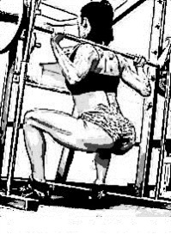
 | 2nd Workout: light | 2nd Workout: light
Forward Lunges | 1st Workout: heavy | 1st Workout: heavy
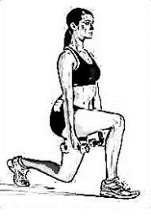
 | 2nd Workout: light | 2nd Workout: light
Deadlifts | 1st Workout: heavy | 1st Workout: heavy
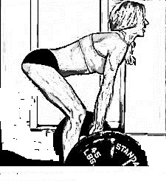
 | 2nd Workout: light | 2nd Workout: light
Cable Kickbacks | 1st Workout: heavy | 1st Workout: heavy
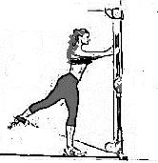
 | 2nd Workout: light | 2nd Workout: light
Leg Press-narrow | 1st Workout: heavy | 1st Workout: heavy
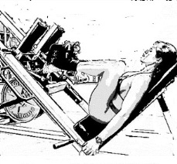
 | 2nd Workout: light | 2nd Workout: light
1st Workout of the Week - (heavy, low reps) - 3 sets x 6-8 reps x weight
2nd Workout of the Week - (light, high reps) - 4 sets x 10-15 reps x weight
*Rest 3-4 days between 1st and 2nd Workout for each week.
*Use the heaviest weights possible to complete each exercise. Use dumbbells, kettlebells, and ankle weights. Go deep!

Gain up to 2 ½ “ to your Butt with the Better Butt Program

Gym Best Butt Exercises for Women

12 Week Workout Routine & Log
Exercises | Week 3 | Week 4
Squats - wide | 1st Workout: heavy | 1st Workout: heavy
 | 2nd Workout: light | 2nd Workout: light
Forward Lunges | 1st Workout: heavy | 1st Workout: heavy
 | 2nd Workout: light | 2nd Workout: light
Deadlifts | 1st Workout: heavy | 1st Workout: heavy
 | 2nd Workout: light | 2nd Workout: light
Cable Kickbacks | 1st Workout: heavy | 1st Workout: heavy
 | 2nd Workout: light | 2nd Workout: light
Leg Press-narrow | 1st Workout: heavy | 1st Workout: heavy
 | 2nd Workout: light | 2nd Workout: light
1st Workout of the Week - (heavy, low reps) - 3 sets x 6-8 reps x weight
2nd Workout of the Week - (light, high reps) - 4 sets x 10-15 reps x weight
*Rest 3-4 days between 1st and 2nd Workout for each week.
*Use the heaviest weights possible to complete each exercise. Use dumbbells, kettlebells, and ankle weights. Go deep!

Gain up to 2 ½ “ to your Butt with the Better Butt Program

